**Detecting the movement of objects with webcam**

**ABSTRACT :**

Various Methods Are Used In Motion Detection Of A Particular Interest. Each Algorithm Is Found Efficient In One Way. But There Exists Some Limitation In Each Of Them. This Paper Proposes A Method For Detecting The Motion in a Particular Region Being Observed. The Motion Tracking Surveillance Has Gained A Lot Of Interests Over Past Few Years. This System Is Brought Into Effect Providing Relief To The Normal Video Surveillance System Which Offers Time-Consuming Reviewing Process. Through The Study And Evaluation Of Products, We Propose A Motion Tracking System Consisting Of Its Method For Motion Detection . In Our Proposed System Those Disadvantages Are Omitted And Combining The Usage Of Best Method We Are Creating A New Motion Detection Algorithm For Our Proposed Motion Tracking System.

**EXISTING SYSTEM :**

Digital surveillance systems are mostly specifically designed for commercial use and it has always been out of reach for other users. The cost for CCD cameras,networking devices and the software designed for this system has made it inaccessible and impractical for home users with moderate requirements. Also, not all the existing products have the motion detection function. In traditional systems for security operations, cameras are used to deliver analogue video images to monitors or time-lapse video cassette recorders (VCR). Although many local image processing functions are possible to improve the system application, this requires a lot of processing resources and high-power-consuming hardware. Although Digital video surveillance and security systems are widely used, analogue systems still serve as a cheaper alternative.

**DISADVANTAGES OF EXISTING SYSTEM :**

1.Used for Commercial purposes.

2. Inaccessible to the other users(common people).

3. CCD cameras, networking devices are Expensive.

4. Absence of motion detection functionality.

5. Requires a lot of processing resources.

6. Archive space used to store videos is too high.

7. Manual monitoring of videos is Time consuming.

8. Requires high-power-consuming hardware

9**.**Less accuracy

10.low Efficiency

**PROPOSED SYSTEM :**

In this we are going to write a python program which is going to analyse the images taken from the webcam and try to detect the movement.Videos can be treated as a stack of pictures called frames. Here I am comparing different frames(pictures) to the first frame which should be static(No movements initially). We compare two images by comparing the intensity value of each pixel.In my project,I used Python Programming Language and its most important and specific libraries OpenCV which is most required for solving problems related to images and videos and this is an Open Source Computer Vision based personal project to detect Human Faces and different objects coming in front of the webcam for a specific time frame.This python scripts detects movement on your web-cam and outlines the moving object on your computer screen.

**ADVANTAGES OF PROPOSED SYSTEM :**

1. Requires less memory.

2. Analysis is done automatically.

3. Alert systems may be implemented automatically when the motion is detected.

4.High accuracy

5.High efficiency

**SYSTEM ARCHITECTURE :**

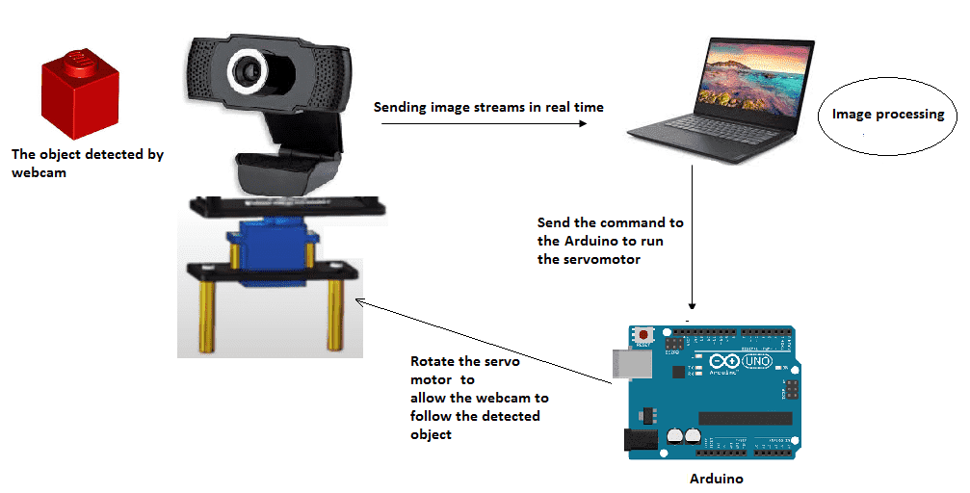

**HARDWARE & SOFTWARE REQUIREMENTS:**

**HARD REQUIRMENTS :**

* System    :   i3 or above
* Ram    :   4GB Ram. \
* Hard disk : 40GB

**SOFTWARE REQUIRMENTS :**

* Operating system   : Windows
* Coding Language  : python